
Mid Devon Community Family Trust

Equal opportunities

Aims
Mid Devon Community Family Trust offers relationship education to anyone who would like it. We aim to have an atmosphere of friendship, respect and care for each other. In particular, we aim to treat every volunteer and client equally, regardless of their age, disability, gender reassignment, marriage or civil partnership, pregnancy or maternity, race, religion or belief, sex, or sexual orientation
Accessibility
All our meetings and events are held in venues that are accessible to wheelchair users or online. When there are more than 40 people at an event we aim to use a PA system and a hearing loop.
We are committed to ensuring any client is able to attend our activities, so we will reassess our access requirements to meet the needs of new tenants. The service is a preventive service and clients are assessed to ensure that their needs are not too great for the organisation to be able to support
Diversity
Providing that client needs are not beyond the expertise of the relationship educators, counsellors, or student counsellors everybody is welcome to access the service regardless of disability race culture religion or gender
Inclusion and respect
Every volunteer or client should be made to feel equally welcome and included at all points of the service
Sexist, racist, homophobic, transphobic or otherwise offensive and inflammatory remarks and behaviour are not acceptable. These constitute harassment and have no place in the work of the trust.
Ex-Offenders
We only ask an individual to provide details of convictions and cautions we are legally entitled to know about.
A thorough risk assessment has been conducted before deciding it is both proportionate and relevant to the position concerned to apply for a Standard or Enhanced DBS check, also ensuring the role is legally eligible for one of these types of check
For those positions where a DBS check is identified as necessary, all application forms and other relevant recruitment documentation will contain a statement that an application for a DBS certificate will be submitted in the event of the individual being offered the position
We undertake to treat all applicants for positions fairly and do not discriminate unfairly against any subject of a criminal record check on the basis of a conviction, caution or other information revealed and that an open and measured discussion takes place on the subject of any offences or other matter that might be revealed on a DBS check where it is not explicit in the policy that such information would be a barrier to employment
The organisation abides by the DBS Code of Practice and/or the Basic check: Processing standards
We actively promote equality of opportunity for all with the right mix of talent, skills and potential and welcome applications from a wide range of candidates, including those with criminal records
All candidates are selected for interview based on their skills, qualifications and experience

Dealing with discrimination and harassment
If any person feels they have been discriminated against by the Trust or harassed at a Trust event they should raise this with the Relationship Educator – Designated person or Trustees.
The committee will investigate the complaint, listening to all members involved. (If the complaint is against a Trustee, that Trustee will not be part of conducting the investigation).
If the complaint is against a particular individual, this person will have the opportunity to express their point of view, accompanied by a friend. The person making the complaint will also have this opportunity.
If the complaint is against the Trust as a whole, the Trustees must work to ensure that such discrimination is not repeated in the future and must inform the members of how they propose to do this.
Any decision to exclude a person from the organisation due to discriminatory or harassing behaviour will be made with reference to the Trust’s constitution. The Trust will support people who feel they have been harassed or discriminated against, and will not victimise or treat them less well because they have raised this.
Designated person
Vivien Southall 01884266607 vjsouthallmdcft@yahoo.com
Bridge House, Fore Street, Kentisbeare, Devon EX15 2AD

Review

Date policy written 10.10.2023

Date approved by MC:……12.10.2023…..

Signed by the designated person………William Wheeler…………………………….

Date of review: A year after it was written/approved………August 2024………..

Reviewed February 4th 2025
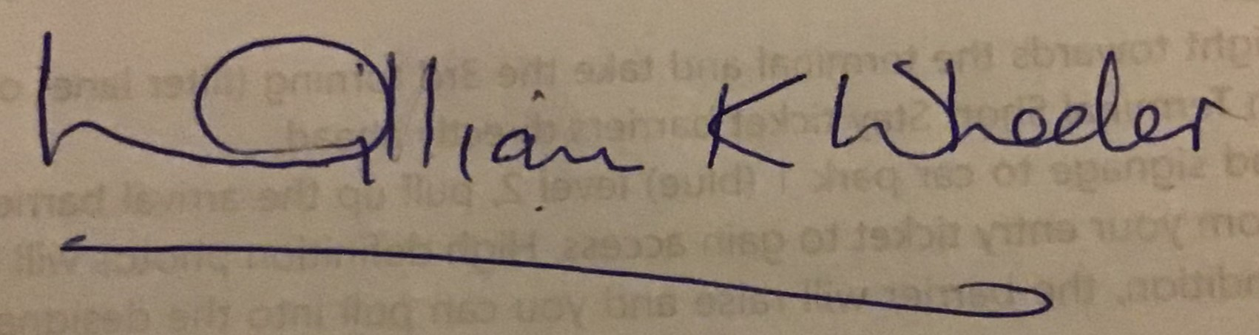
Signed by Designated person

Signed by William Wheeler

Reviewed

Signed by Designated person

Signed by

